ASSIGNMENT 14

1) Write a command that puts the following values, in their given order, into the salespeople table:
city – San Jose, name – Blanco, comm – NULL, cnum– 1100.

insert into SALESPEOPLE (City,Sname,Comm,Cnum)
-> values('San Jose','Blanco',NULL,1100);
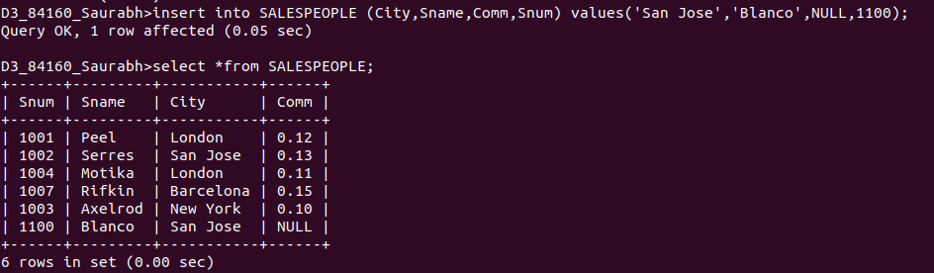

2) Write a command that removes all orders from customer Clemens from the Orders table.

delete ORDERS from ORDERS, CUSTOMERS where ORDERS.Cnum = CUSTOMERS.Cnum and Cname = 'Clemens';
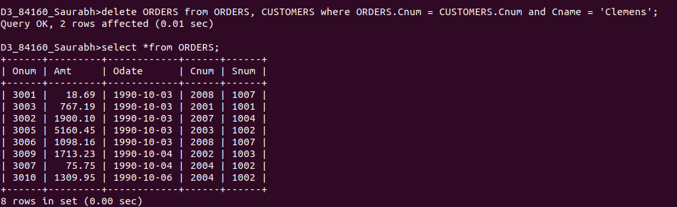
3) Write a command that increases the rating of all customers in Rome by 100.

update CUSTOMERS set Rating = Rating +100 where City = 'Rome';

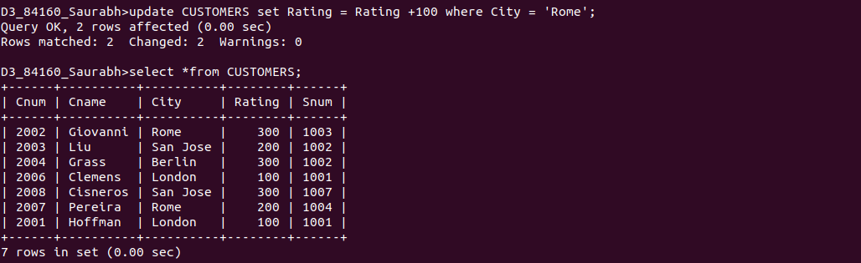

4) Salesperson Serres has left the company.Assign her customers to Motika.

update CUSTOMERS set Snum = (select Snum from SALESPEOPLE where Sname ='Motika') where Snum = (select Snum from SALESPEOPLE where Sname = 'Serres');

